Board of Directors  Linda Foreman  President  Sandy Thomas  Vice President  Kaitlin Singer  Secretary  Ellen Petrino  Treasurer  Jennifer Allebach  Susan Anderson  Sandy Craighead  Alice Hahn  Marnye Hall  Joyce Knoll  Sue McNab  Laura Robert-Rivera  Diane Saber  Barbara Schliebe  Barbara Sirvis  Directors Emeritae  Catherine Corbin  Phylis Crook  Lisa Hinshaw  Connie Matsui  Carolyn McCallum  LaRae Orullian  Martha Smith  Mary Ellen Snow  Tricia Tilford | February 28, 2026  Annual Report to the Members  From the Board of Directors for the Fiscal Year Ended September 30, 2025  On behalf of the Board of Directors of the World Foundation for Girl Guides and Girl Scouts, Inc., I am pleased to present this report to the Members for the fiscal year October 1, 2024, to September 30, 2025.  The Annual Meeting of Members of the World Foundation for Girl Guides and Girl Scouts, Inc. was conducted on March 1, 2025, at the Edith Macy Conference Center, Briarcliff Manor, NY, for the purpose of electing members to the Board of Directors, receiving the Report of the President, and conducting business.  Board elections were held. The following individuals were elected unanimously:  Nominated by GSUSA: Sue McNab, second 3-year term  Jennifer Allebach, first 3-year term  Marnye Hall, first 3-year term  Nominated by WAGGGS: Katie Singer, second 3-year term  Nominated Officer: Katie Singer, to continue as Secretary  Reappointed Proxies: GSUSA – Sue McNab  WAGGGS – Sandy Thomas  Meetings of the Board of Directors were held on the following dates:  October 8, 2024, via Zoom March 1, 2025, Annual Meeting  October 31, 2024 June 10, 2025, via Zoom  December 10, 2024, via Zoom September 25, 2025, Working Session February 18,2025, via Zoom via Zoom
The Board of Directors is appreciative of the leadership of our five Friends Committees:
Friends of Nuestra Cabaña USA: Patty Cook, President ,and Rebecca Daniels, Vice-President
Friends of Our Chalet USA: Terri Bone and Diana Sullivan, Co-Chairs
Friends of Pax Lodge USA: Maureen Lienau and Sarah Edwards, Co-Chairs and
Barbara Johnson and Lisa Ferreira, Co-Vice Chairs
Friends of Sangam USA: Bambi Hora and Allison Kaufman, Co-Chairs
Friends of WAGGGS USA: Kandi Lancaster, Chair. and Gail Lamotte, Vice-Chair

Each committee sets annual fundraising and membership goals.

The Friends’ Committees comprise over 150 volunteers whose mission is to promote and support global opportunities for girls and young women to experience cultural competency and awareness through initiatives that enable inspiration, connection, experiential learning, and development of skills and understanding.

Donors are the lifeblood of the World Foundation's capacity to support both WAGGGS and GSUSA. The World Foundation is grateful to the 793 donors who supported our work this past year. Donors are: members of Friends Committees, OBPS supporters, board members and longtime general supporters of our mission.

Fiscal Year End 2025 Financial Statement, Contributions, and Grants Awarded:
During the fiscal year, October 1, 2024, to September 30, 2025 (FY25), the World Foundation posted total revenues of $2,505,072, expenses of $88,000, and total assets of $4.2 million. Contributions totaled $2,242,345, including an extraordinary $1,288,765 in bequests from a single individual benefitting WAGGGS and the World Foundation. The remaining revenue was from event fees ($14,770) and investment income ($247,957).

In FY25, the Board of Directors awarded grants totaling $1,285,310, of which $1,175,310 was awarded to WAGGGS and $110,000 to GSUSA.

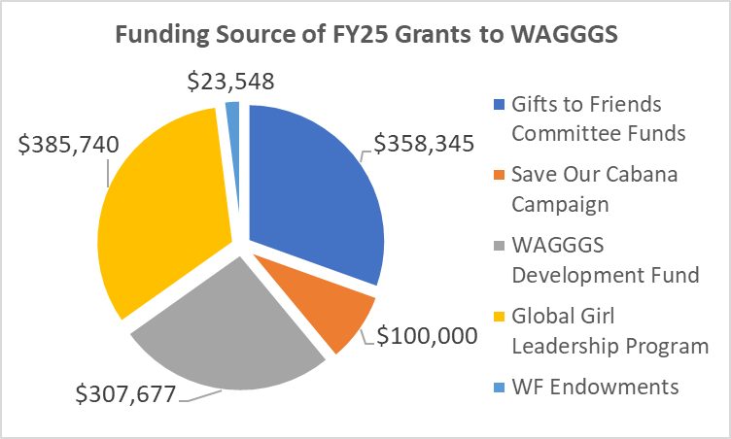
Summary of Projects Funded by FY25 Grants to WAGGGS:
- World Centre operations, programs and capital projects, including Nuestra Cabaña reopening
- Leadership Programs at World Centres (including volunteer programs, Juliette Low Sessions both in person and virtual, Helen Storrow Session) and the advocacy program for UN Commission on the Status
of Women
- Global Girls Leadership Program
- WAGGGS strategic priorities, including capacity building, Campfire, Growing and Learning, advocacy, support to Member Organizations
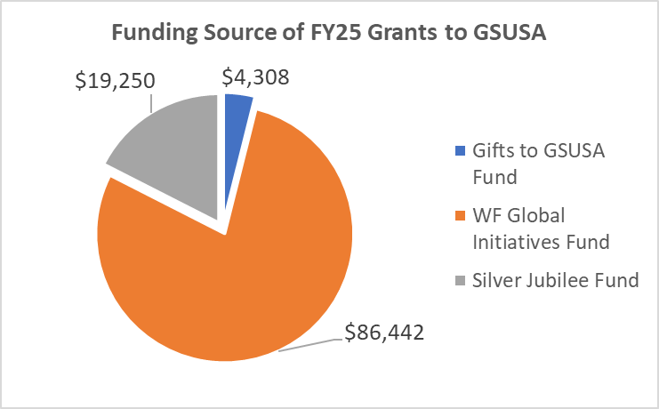
Summary of Projects Funded by FY25 Grants to GSUSA:
- USAGSO operations, community camps, camp at Nuestra Cabaña, microgrants, and leadership and volunteer support
- Two GSUSA meetings supporting the new Global Citizen program

Note: A $10,000 grant awarded to GSUSA in FY24 (for a project that WAGGGS took on) was rescinded in FY25.

The specific source of funding for each type of grant is detailed in the Appendix.
We could not do this work without our donors. A total of 793 donors gave 1,929 gifts in FY25. One donor's various bequests totaled $1.3 million representing 57% of our fundraising for the year. Of the $968,490 given by all other donors, which was a 5% increase over last year, 73% was given by Friends Committee members, World Foundation Board members and members of the Olave Baden-Powell Society (OBPS). The remaining 23% was given by solicited donors and the public, comprising 70% of the total number of donors and 42% of the total number of donations. THANKS!! to all of our donors.

World Foundation Highlights
The World Foundation’s work centers on 3 strategic goals:
- Relationships
- Presence
- Organizational Excellence

Relationships: Members, Friends, Donors
Regular and strategic communication with our Member partners is critical to the World Foundation’s mission. Regular as well as timely, issue-oriented communications support strong relationships. The World Foundation is especially grateful to be engaged in the development of the GSUSA Global Strategy and 2026 GSUSA convention opportunities. New WAGGGS leadership has created opportunities to expand our partnership. A robust grant process assures strong communication and shared accountability.

The World Foundation supports all of the Friends Committees with zoom account access, cross committee communications, periodic update meetings, and welcome and orientation communications for new committee members. The Program Coordinator provides ongoing support to Friends’ groups and individual members and donors.

The World Foundation continues to promote its Mission and share its successes via its quarterly newsletter “What’s Happening.” Friends and donors are updated about the collaborative work with WAGGGS and GSUSA as well as stories and successes from our Friends’ groups. In addition, Friends’ committees have also generated their own internal electronic communications focused on their committee work and news from the World Centres.

Our website continues to be an important vehicle to share our mission and funding opportunities, WAGGGS initiatives, Friends Committee fundraisers and connection opportunities. Friends Committees continue some pandemic-originated opportunities such as virtual tours and culinary events. The World Foundation continues its presence on social media platforms Facebook and LinkedIn.

We continue to be grateful for the in-kind support provided by GSUSA. The use of the GSUSA mailing address, and access to office space, email and SharePoint for our Program Coordinator and Treasurer enable the World Foundation to minimize operational expenses and thus maximize the impact and effectiveness of gifts received to support the Mission.

Presence: Places and Spaces
The World Foundation, through board members, friends and donors, is represented on several WAGGGS Committees and working groups and in the continuing work of the GSUSA global strategy. For the first time, the World Foundation is listed as a GSUSA funding partner. The USAGSO 100th anniversary, the Western Hemisphere Conference and the Global Citizen/USAGSO event at Nuestra Cabaña had participation and support from the World Foundation.

The World Foundation is excited to plan engagement in the 2026 WAGGGS World Conference and the GSUSA National Council and Convention.

Organizational Excellence:
Valerie Pierpoint completed her third year as Program Coordinator. Her primary areas of responsibility include: donor database management, acknowledgements and reporting, communications with Members, Friends groups and the board, support to committees and task groups, newsletter development and support for virtual and in-person meetings of the board, task groups and the annual gatherings.

Committees and task groups support the work of the World Foundation
- An Executive Committee meets regularly to support ongoing work and planning.
- The Finance Committee assures the responsible reporting, management and disbursement of funds. The World Foundation continues to streamline its systems and processes including the Salsa platform which facilitates on-line giving, enables greater analysis and supports individual and small group fundraising efforts.
- A Grant Review Task Group continues to lead and strengthen the critical process related to our fundamental responsibility to donors and Members. It leads both the process of grant application and report review as well as streamlining the process for all.
- Communications was a major focus with a task group developing a master plan and first-ever “Impact Report”.
- The Fund Development Task Group continues its focus on providing education and support as requested by Friend’s groups as well as enabling opportunities for individual fundraising.
- Similarly, the Board Development Committee continued its work to bring high quality candidates to the board and assure that board members have the tools and information they need for maximum engagement and effectiveness.

The World Foundation remains committed to our Mission to support projects and programs that enable girls and young women to develop their fullest potential as responsible citizens of the world.
Our partners and donors fuel our mission. Thank You!

Respectfully submitted
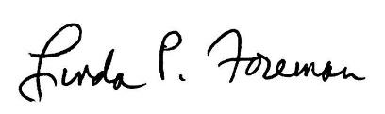
Linda P Foreman, President

CC: Candela Gonzalez, Chair, WAGGGS World Board
Nadine El Achy CEO, WAGGGS World Bureau
Inga Pikse, Head of Philanthropy, and Individual Giving, WAGGGS
Magdalene Thomas, Head of International Operations, WAGGGS
Bonnie Barczykowski, CEO, GSUSA
Noorain F. Khan, President, GSUSA National Board
Meridith Maskara, Chief Development Officer, GSUSA
Sue Santa, Senior Vice President, Public Policy and Advocacy, GSUSA
Adwoa Aidoo, Director of Global Girl Scouting, GSUSA
Kelly Bullard, Executive Director, USA Girl Scouts Overseas
World Foundation Officers and Directors
World Foundation Friends’ Leadership Teams
APPENDIX

Grants are awarded in two cycles, from funds available at calendar year end and at June 30, and as needed. Thus, funds raised in a fiscal year are often granted in the next fiscal year or two. For this reason, grants awarded do not match funds raised in the same fiscal year. The funding sources and purposes for which grants were awarded in FY25 included:

Grants Awarded to WAGGGS
$258,350 raised by the Friends Committees supporting World Centres:
- Nuestra Cabaña: $85,150 for volunteer leadership development program ($26,000) and essential operating costs ($59,150)
- Our Chalet: $93,650 for volunteer leadership development program for 40-45 young women ($77,145); scholarship and travel support for 16 leaders from Member Organizations ($16,505)
- Pax Lodge: $34,250 for volunteer leadership development program for 17 young women
- Sangam: $43,700 for scholarships for 5 leadership events
- Kusafiri: $1,600: for volunteer leadership development program
$100,000 raised in a global “Save Our Cabaña” campaign organized by the leadership of Friends of
Nuestra Cabaña, plus $10,722 in distributions from endowments dedicated to Nuestra Cabaña, for use in its reopening, including staffing, program delivery and maintenance
$99,995 raised by Friends of WAGGGS USA and awarded for Phase 2 of the Growing and Learning
Initiative ($59,995), promotion of the Capacity Assessment Tool including Campfire costs, program and resource development consultants, and identifying facilitators for forums in Arab. Africa and Asia Pacific regions ($20,000), and promotion of the Gender Equality UN Challenge Badge ($20,000)
$693,417 raised by WAGGGS through its various appeals, including OB-PS membership and events
- $267,510 for WAGGGS 2025 operations plus $12,826 in distributions from endowments dedicated to WAGGGS
- $385,740 for Global Girls Leadership Program
- $32,826 to support young delegates to the UN Commission on the Status of Women and COP30
- $7,341 in other WAGGGS support, including delivering the Capacity Assessment Tool in person ($7,336) and Phase 3 of Growing and Learning Initiative ($5)

Grants Awarded to GSUSA
$86,442 raised by the World Foundation for the Global Initiatives Fund
- $26,247 for GSUSA Global Citizen research, including a meeting at Nuestra Caba$ñ$a ($10,000) and partial funding of a pre-conference leading to Convention ($16,247)
- $7,200 for USAGSO Passport to the World project of large-scale camps
- $52,995 for USAGSO Girl Leadership and Volunteer Training and Support projects, including volunteer retreats ($10,125), leadership training ($4,870), microgrants for local activities ($30,000), and community growth and expansion ($8,000)
$19,250 granted from the World Foundation Silver Jubilee Fund, which was established to fund
international camping opportunities, to support USAGSO Passport to the World projects, including Globetrotter, an adventure camp/travel troop ($10,250) and USAGSO day camps in Okinawa, Japan and South Korea ($9,000)
$4,308 raised from donors to the World Foundation GSUSA Fund for partial funding of the GSUSA Global
Citizen research project’s pre-conference leading to Convention

